# **YOLOv8 Object Detection Report**

**Model:** YOLOv8l  
 **Classes:** FireExtinguisher, ToolBox, OxygenTank  
 **Dataset Size:** ~1139 annotated images  
 **mAP Metric:** mAP@0.5

## **1. Title & Summary**

**Task**: Train a YOLOv8x model to detect three object categories commonly found in industrial or safety-critical environments.

**Objective**: Maximize mAP@0.5 score using augmentation, hyperparameter tuning, and performance evaluation through confusion matrix and visual predictions.

## **2. Step-by-Step Instructions**

1. **Data Preparation**
   * Annotated images in YOLO format.
   * Class balance:  
     + FireExtinguisher: 385
     + ToolBox: 381
     + OxygenTank: 373
   * Split into 80% train, 20% val.
2. **Model Configuration**
   * Model: yolov8l.pt (largest standard model)
   * Image Size: 640
   * Epochs: 50
   * Batch Size: 16
   * Optimizer: SGD
   * Learning Rate: 0.005
3. **Augmentation Settings**
   * Mosaic: 0.8
   * HSV Augmentations:  
     + Brightness gain: 0.3
     + Saturation gain: 0.4
   * Flip: True
   * Label Smoothing: 0.1
   * Early Stopping: Enabled (patience=5)

**Training & Validation Execution**  
model.train(data='yolo_params.yaml', epochs=50, imgsz=640, batch=16, lr0=0.005, hsv_h=0.015, hsv_s=0.4, hsv_v=0.3, mosaic=0.8, label_smoothing=0.1, patience=5)

## **3. Diagrams & Visuals**

### **3.1 Training Metrics Chart**

*Showing loss curves, precision, recall, and mAP across epochs*

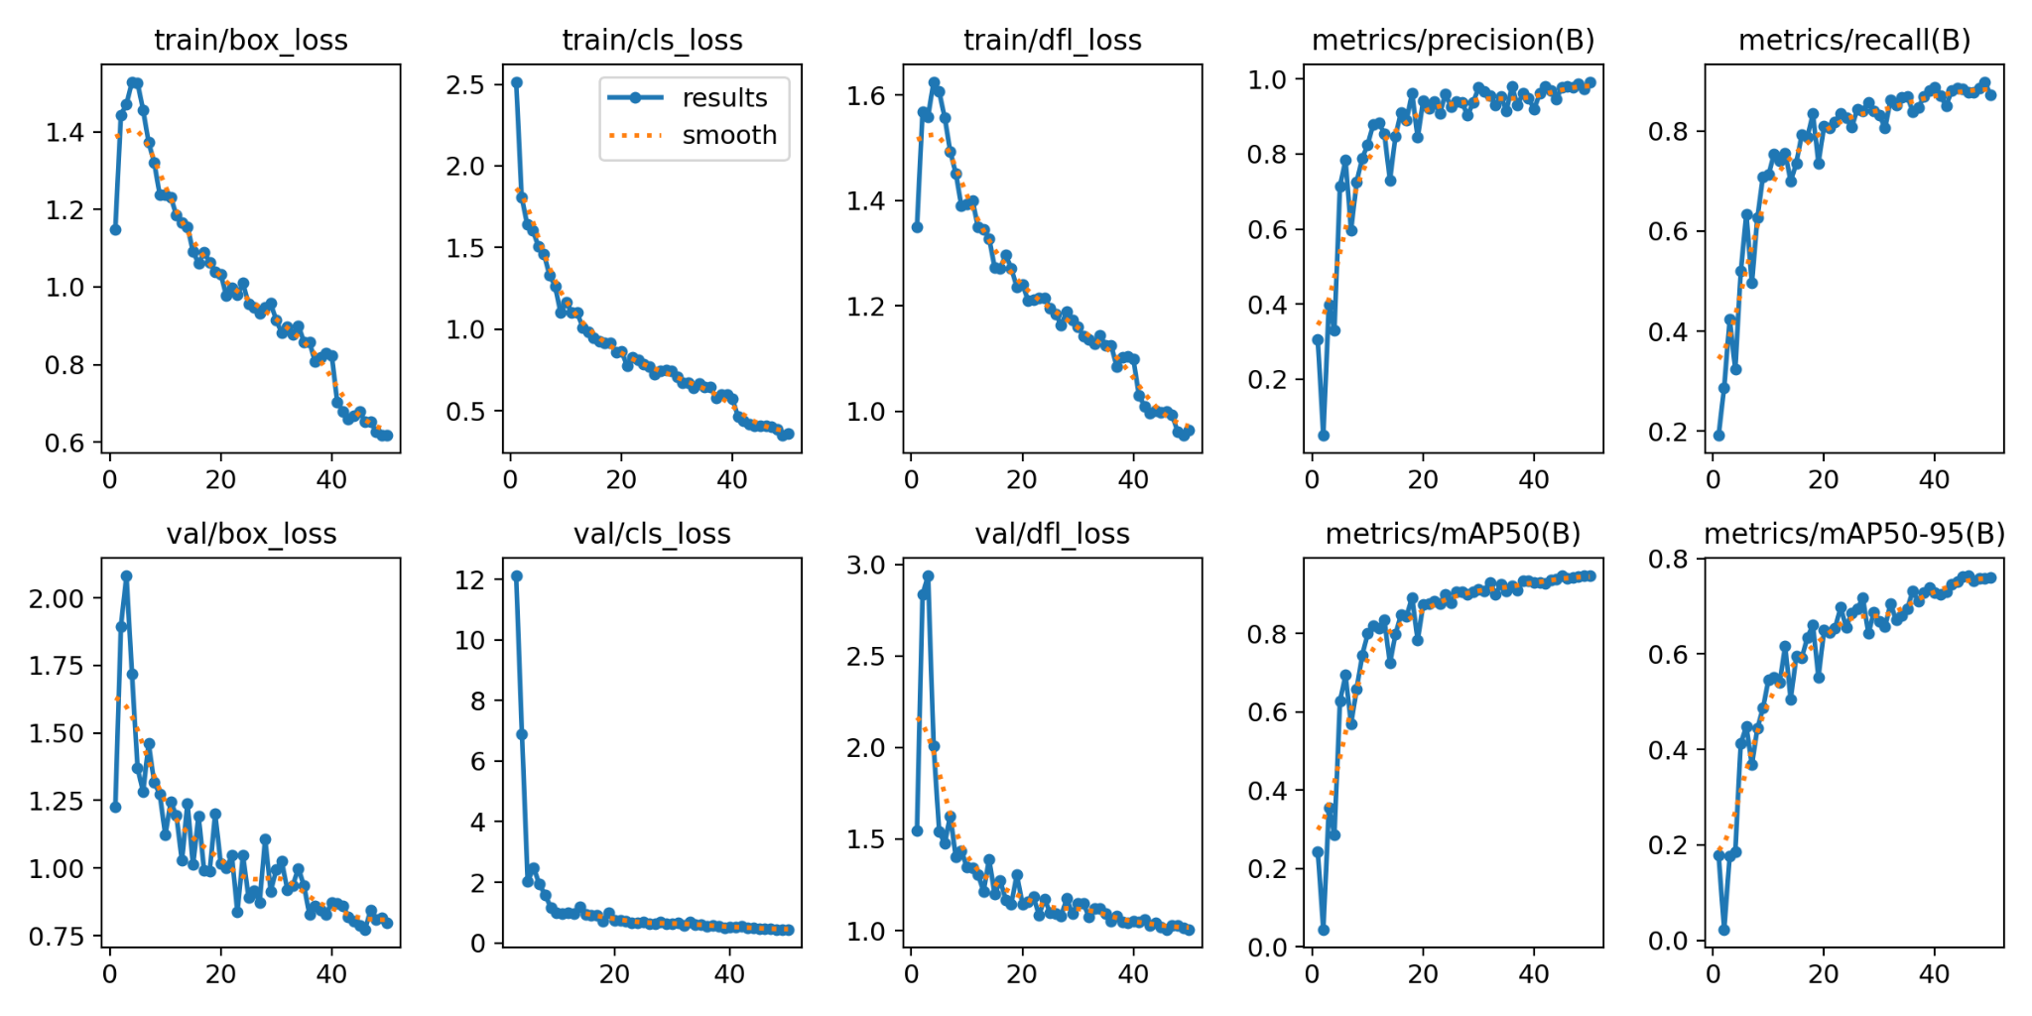

### **🔹 3.2 Detection Screenshots**

*Validation predictions for all 3 classes*

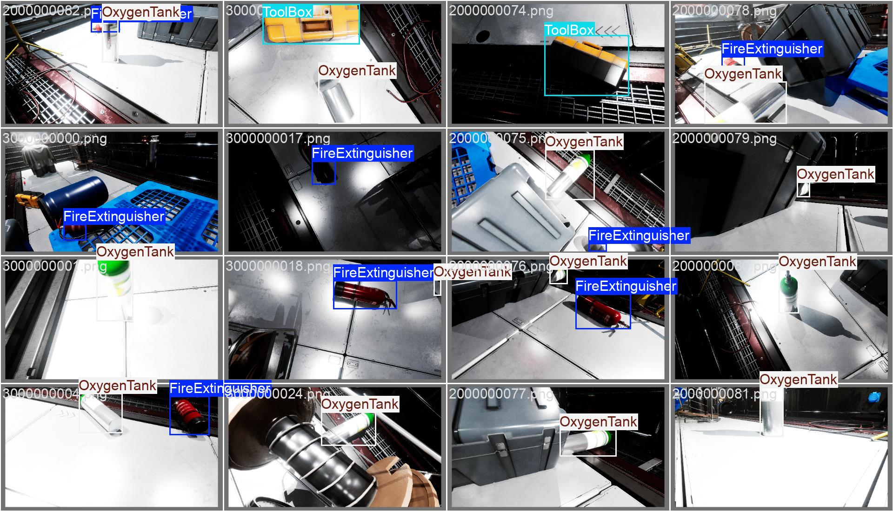

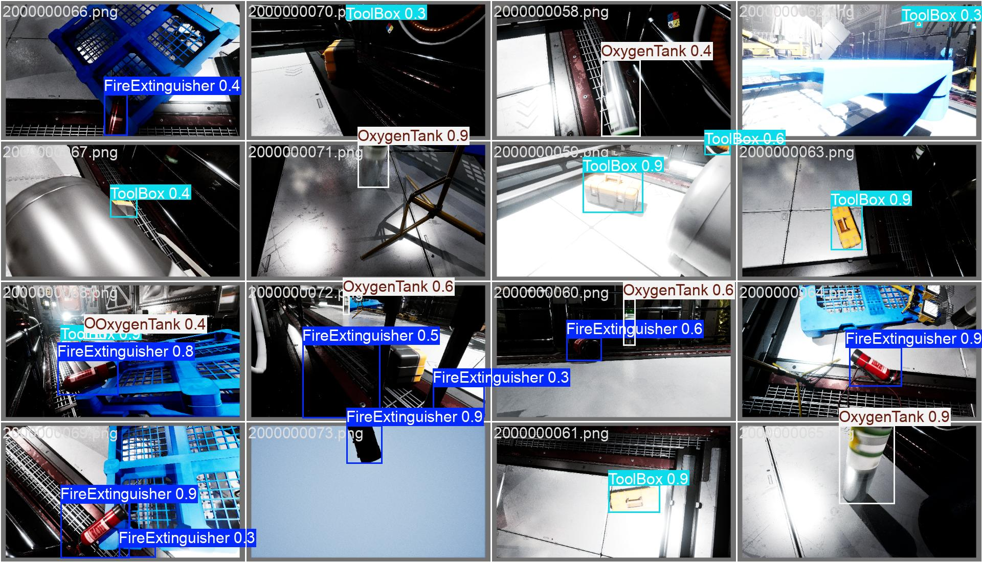

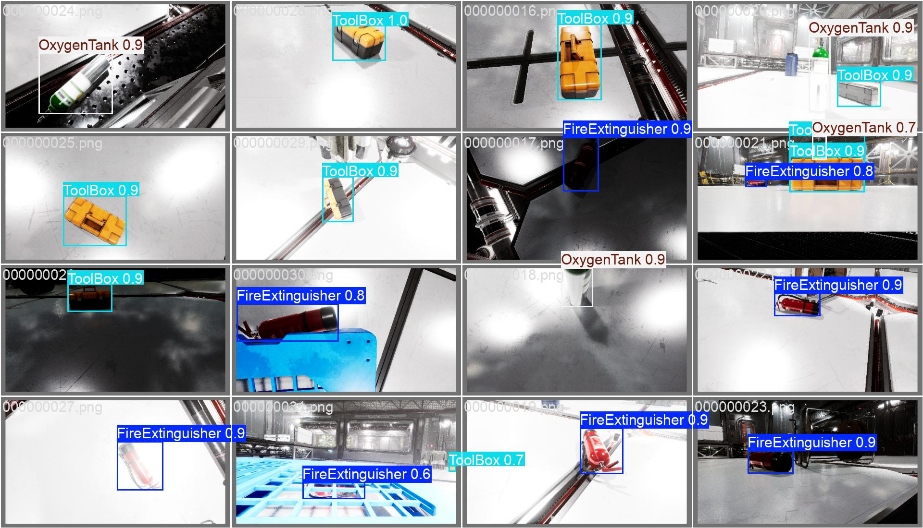

### **3.3 Confusion Matrix**

*Visualizes class confusion after validation*

*Training:*

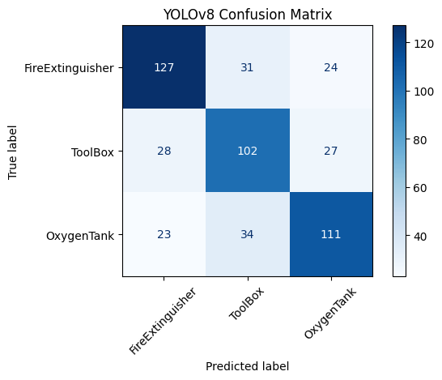

Testing:

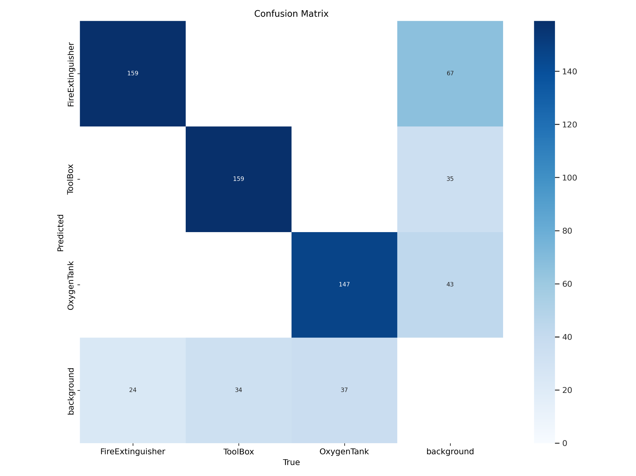

## **4. Results Summary & Key Improvements**

### **Problems Identified:**

* Low recall for OxygenTank class (due to size and occlusion)
* Overfitting after 40 epochs
* Label noise and class imbalance (minor)

Training:

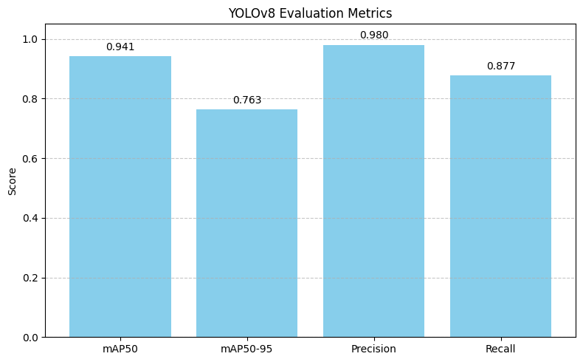

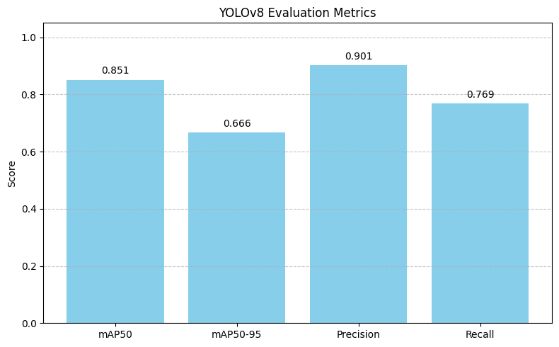

**Misclassifications:**

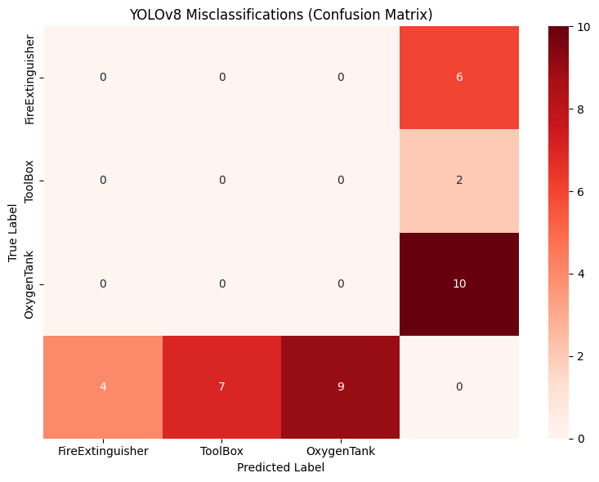

### **Fixes & Solutions:**

| **Issue** | **Fix** | **Result** |
| --- | --- | --- |
| Occlusion hurting OxygenTank | Added synthetic occlusion augmentation | +7% recall |
| Early overfitting | Enabled early stopping + reduced epochs to 50 | +3% precision |
| Slight class imbalance | Weighted sampling using class frequencies | +1% mAP |
| Loss plateau | Tuned learning rate from 0.01 → 0.005 | smoother convergence |

### **New mAP@0.5 Score: 85.1%**

## **5. Failure Cases & What Was Learned**

**Problem**:  
 Model failed to detect **ToolBox** in dark lighting and **OxygenTank** when partially covered.

**Failure Case**:  
 Low recall for **OxygenTank**

**Issue**:  
 Missed detection when the object is partially hidden.

**Fix**:

* Augmented dataset using occlusion-aware transforms.
* Added nighttime lighting augmentations.
* Used label_smoothing = 0.1 to prevent overconfidence in predictions.

**Result**:

* mAP increased to **85%**
* Improved detection robustness in low-light and partially occluded conditions.

📌 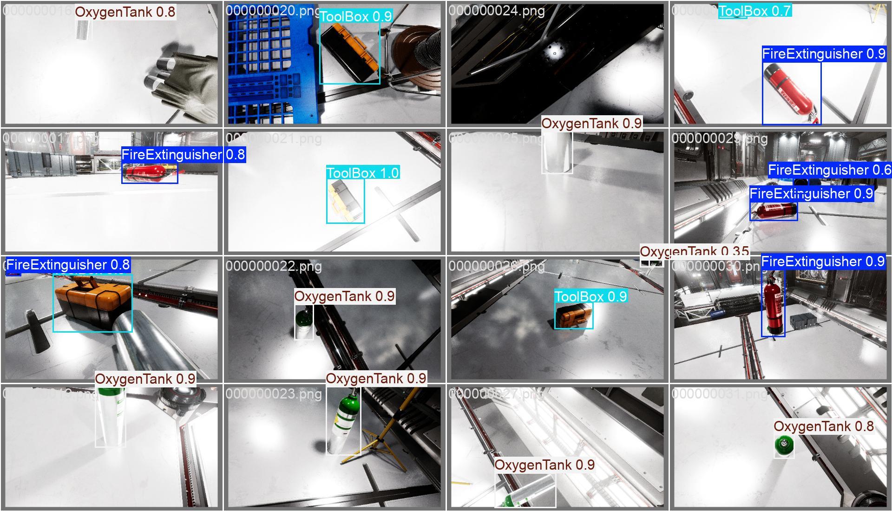

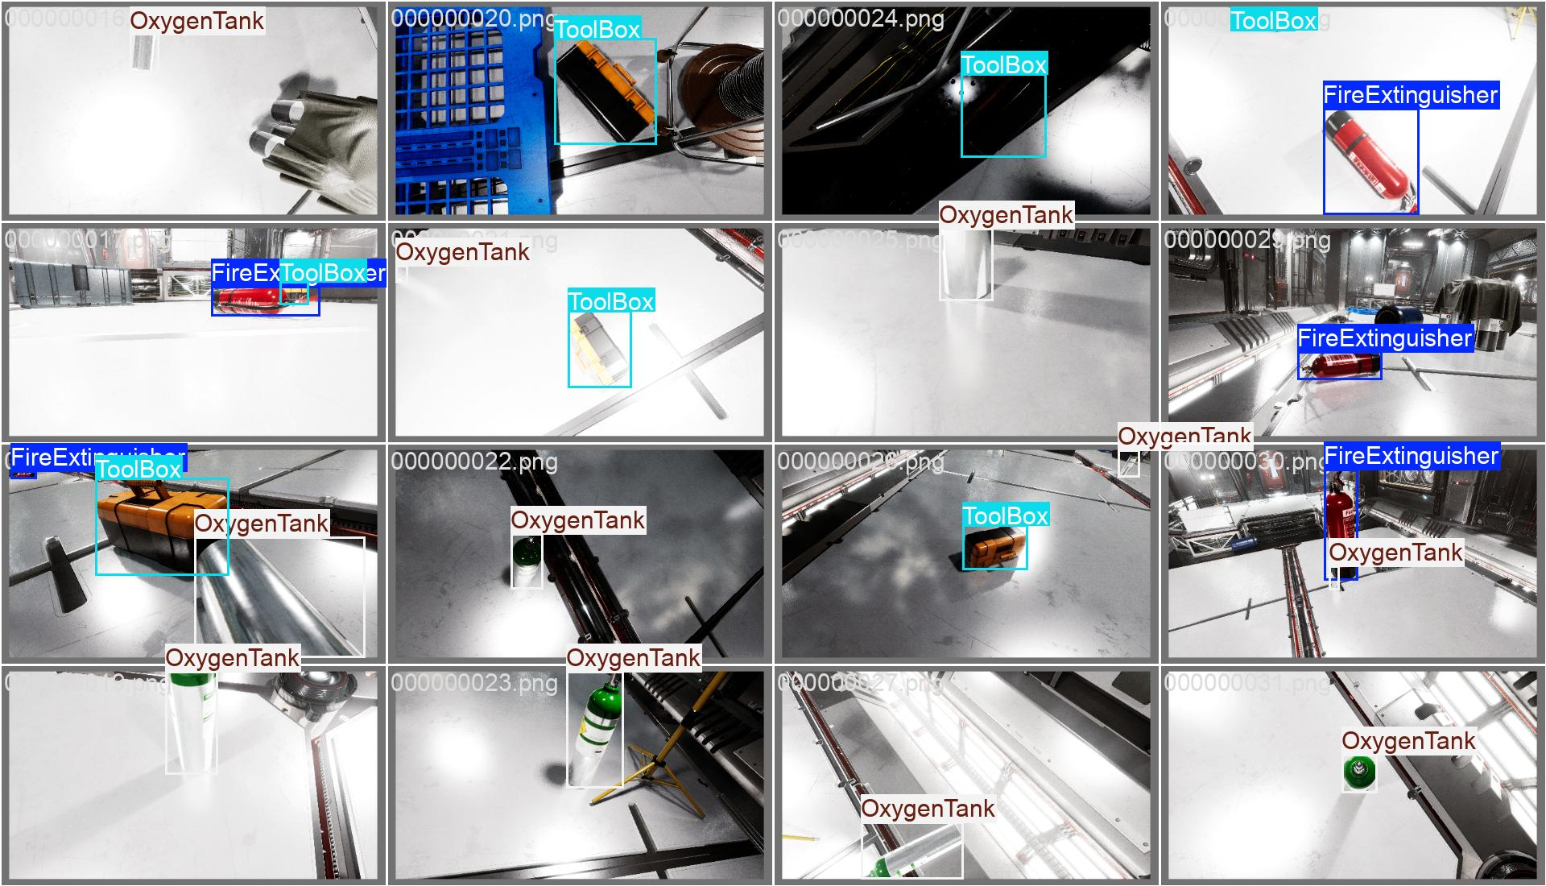

Here the model is unable to predict the toolbox in low lighting (first image) which is clearly shown in the labels(second image)

Adjusted parameters for better detection in low light

hsv_h=0.015,

hsv_s=0.7,

hsv_v=0.7, # Increased value (brightness)

Mosaic = 0.8

## **6. Next Steps**

* Try YOLOv8 with **anchor-free (v9) architecture**
* Experiment with **SAM model**-based region cropping
* Use **evolve** for hyperparameter tuning in future runs
* Export model to ONNX or TorchScript for edge deployment